**2024 Schuyler County Fair**

**Pee Wee Livestock Show**

**July 3, 2024 at 5:30 p.m.**

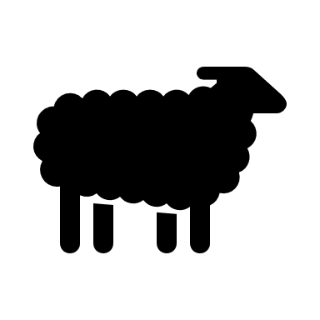

**This show is open to children ages 3 - 8 years old. There is no entry fee.**

Exhibitor information:

1. The child must be at least 3 years old, but not over the age of 8 years old as of the date of the show.
2. One entry per person. Written parent/guardian permission is required. The consent form will be available at the show,
3. Each participant must be accompanied by someone over the age of 16, who is experienced with the animal.
4. Children may show one animal from the following species:

cattle, goats, sheep, swine, or rabbits. The cattle, sheep, and goats must be shown with a halter. Animals do Not have to be owned by the Pee Wee exhibitor. Animals MAY be currently entered in the Schuyler County Fair. Those animals not currently entered in the Schuyler County Fair, being used for the Pee Wee Livestock Show only, are allowed on the grounds for the duration of the show, but must be removed no later than one hour after the end of the show.

1. Ribbons will be awarded to all participants.

Superintendents: Steve Hood 309-333-0738; Gary Wenger 217-248-9440